I. OBJECTIVES

- Explore the function of a linear variable differential transformer (LVDT) functions as a displacement measuring device
  - Explore inductive loading experienced in a circuit and see what effect this has on measured amplitude of driving frequency supplied by the function generator
  - Find the best driving frequency with respect to GAIN (mV/V)
  - Explore how to reduce the noise in a signal using averaging
  - Find the “null position” with respect to a marked gage (ruler)
- Conduct a simple static calibration of the “constructed” LVDT
  - Determine the voltage vs. displacement curve over a 10 cm range
  - Determine the sensitivity constant using linear regression analysis.

Background – Consult textbook and course notes

Setup (Figure 1)

- Prepare the wiring connections for the LVDT primary and secondary coils
- The output of the function generator is split to go to the primary coil and to Channel 1 of the oscilloscope
- The secondary coil(s) are connected as shown and are output to the Channel 2 of the oscilloscope

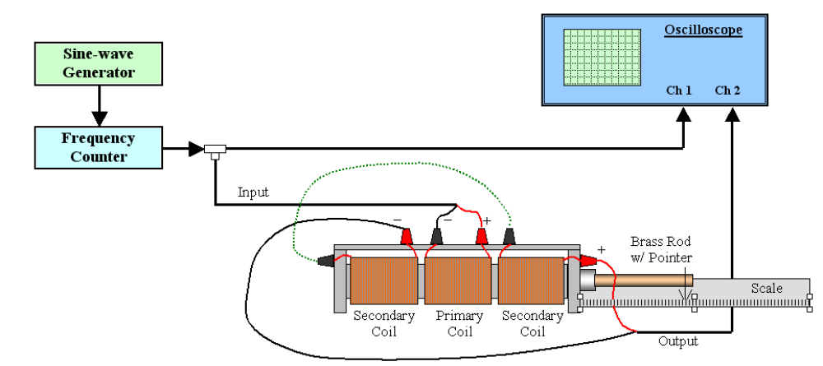
Function Generator

Figure 1 – LVDT Lab Setup Diagram

Activity 1:

- Produce a 10,000 Hz, maximimum amplitude setting, sinusoidal waveform.
- Take two different readings of the amplitude of the output from the function generator.
- One WITHOUT being connected to the primary coil, and one WITH being connected to the primary coil.
  - Measured Voltage_input without coil
  - Measured Voltage_input with coil

- Determine the Percent Difference as

(Measured Voltage_input without coil) – (Measured Voltage_input with coil) x 100
(Measured Voltage_input without coil)

Note: When the function generator is connected to the primary coil, the measured input voltage will drop in amplitude (perhaps significantly), due to the inductive loading of the primary coil.

Activity 2: Using “average” on an o-scope input
The output voltage from the LVDT secondary coils will be low amplitude and fairly noisy. One can take steps to “clean up” the signal trace by averaging the input to Channel 2. By default the o-scope uses a single sample collection (taking 1024 points of data to fill the display window), this can be changed to an average of multiple collections.

- On the oscilloscope menu button, choose ACQUIRE and select averages option, then set averages to 16+.
- DISCUSS what you observe about the quality of the signal displayed on Channel 2 regarding using the single sample setting versus the average setting.

Activity 3: Finding Null position

- Find the null position of the LVDT by moving the iron core in and out of the coil assembly until the lowest (ideally zero) output magnitude is observed from the secondary coils.
- Adjust the position of the metal scale so the pointer on the brass extended rod rests on the 5 cm mark of the ruler.
- This will be the null position of the LVDT throughout the remainder of the lab.
- Secure your scale and LVDT frame to the tabletop for the remainder of the experiment.
- DISCUSS why you cannot use the “zero” position on the ruler.

Activity 4: Determining the best “drive” frequency

Different LVDT sensors respond differently to the input frequency to the primary coil. This activity will explore what happens with the sensors when three different input frequencies are tested.

- Displace the core 5 cm to the right; this will be the 10 cm mark on the scale if the station is set up correctly.
- Record the peak-to-peak voltage magnitudes of the primary coil (input) and the secondary coil (output) waveforms. Refer to Figure 2 for clarification, where V_{pk-pk} of the Primary coil is known as V_{in} and V_{pk-pk} of the Secondary Coils is known as V_{out}.
- Determine the GAIN in units of mV/V, by taking the ratio of the V_{out} (mV) / V_{in} (V)
V_{pk-pk} (Primary)
V_{pk-pk} (Secondary)
Ch 1
Ch 2

Figure 2 – Peak-to-Peak Measurement Reference

- Repeat for 50,000 Hz and 100,000 Hz input frequencies. There is no need to reset the null position.
- Make entries into your spreadsheet using the suggested format for Table 1, see below.
- From Table 1, determine at which of the three input frequencies this particular LVDT displays its maximum Gain.
- Set the function generator to this frequency and leave the input magnitude constant for the remainder of the Challenge.

Table 1 – Frequency and Output Magnitude

Input Frequency  (Hz) | Input Magnitude  V_{pk-pk} (volts) | Output Magnitude  mV_{pk-pk} (volts) | Gain (mV/V)  (mV_{out} / V_{in})
10,000
50,000
100,000

Activity 5: Calibration Data for the LVDT

- Starting at the null position of the LVDT, displace the core to the right (positive) in 0.5 cm increments
  - until you reach a maximum displacement of 5 cm (10 cm on the scale)
- Replicate Table 2 in your excel spreadsheet and record the necessary data as you go along.
- Repeat the process, this time displacing the core to the left (negative).
  - Until you reach a maximum displacement of - 5 cm (0 cm on the scale)

Table 2 – Gain Table

Core Position  cm | Output Mag.  mV_{pk-pk} | Gain  (mV_{out} / V_{in}) | Core Position  cm | Output Mag.  mV_{pk-pk} | Gain  (mV_{out} / V_{in})
0 (null) |  |  | 0 (null)
+ 0.5 |  |  | − 0.5
+ 1.0 |  |  | − 1.0
+ 1.5 |  |  | − 1.5
+ 2.0 |  |  | − 2.0
+ 2.5 |  |  | − 2.5
+ 3.0 |  |  | − 3.0
+ 3.5 |  |  | − 3.5
+ 4.0 |  |  | − 4.0
+ 4.5 |  |  | − 4.5
+ 5.0 |  |  | − 5.0

- Plot the data from Table 2.
  - Plot Gain, (mV/V) on vertical axis and Core Position (cm), -5.0 to 5.0, on the horizontal axis.
- DISCUSS your observations of the plot.

Activity 6: Using Linear Regression to find the sensitivity constant

- Select four representative data points (n=4) from the right side of the graph in order to perform a linear regression least squares data fit.
  - Begin creating Table 3 as shown below in your spreadsheet
  - If necessary, see the instructor for clarification on which points to use.
- Your partner should choose points from the left side of the graph.
  - Thus you will have TWO versions of Table 3, one for the right side (0 to 5.0 cm) and one for the left side (0 to -5.0 cm)
- Calculate the constants a and b for the linear fit Y = a x + b, and the coefficient of determination, r².
  - The formulas for linear regression are shown in the BACKGROUND document.
    - YES, to meet the full Challenge you will use formulas for linear regression explicitly, and not just use an existing function in the spreadsheet.
    - However, you are encouraged to try using the embedded features of excel such as line fit on the plot of data to see how this compares to your computed values
  - The slope, a, is the calibration constant for the LVDT.
    - This value is also referred to as the sensitivity of the LVDT.
    - Commercially, sensitivities for LVDTs are reported as mV/(displacement units)/V_{input}, see sample table on next page.
  - The intercept, b, is an indicator of your null position
  - The coefficient of determination, r², is an indicator of the linearity of your fit

- Additional columns may be added as needed.
- COMPARE the sensitivity values you obtained and DISCUSS your observations.

Table 3 Data for Linear Regression – Right Side

n_{i} | x_{i} | y_{i} | x_{i}y_{i} | x_{i}²
1
2
3
4
Σ:

